Commands:

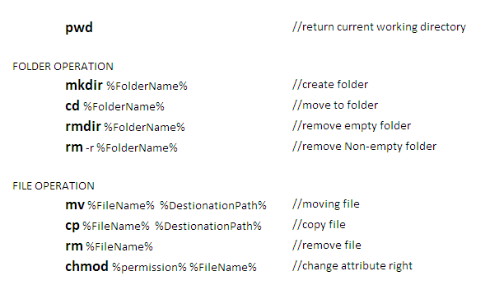

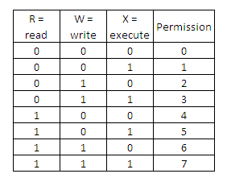

VI

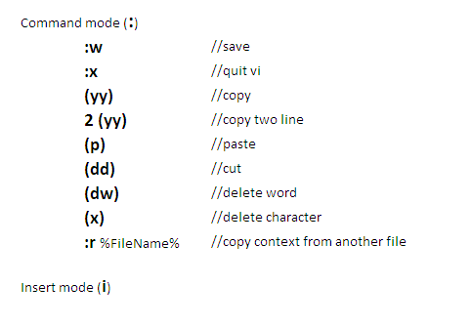

Command1: **date** //display system date

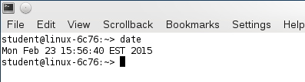

Command2: **cal** // *display system calendar*

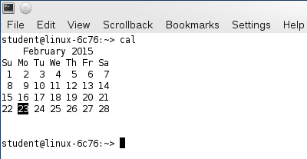

Command3: **who** //see who is logged in

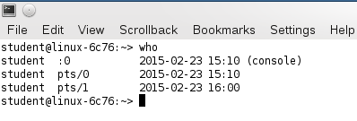

Others Commands:

**Ctrl+Z** *//break*

**man %command%** *//display the manual for the command*

**clear** *//clears the screen*

**date > testFile** *//save the result of command DATE to testFile, if file exist, overwrite it*

**ls >> testFile** *//add context to testFile*

**more testFile** *//read the context of file*

**whatis** *//display a brief description of command*